**Major Concepts Covered**

**Concept Video 10-11:** Types of bonding and Ionic Bonding

**Octet Rule:**

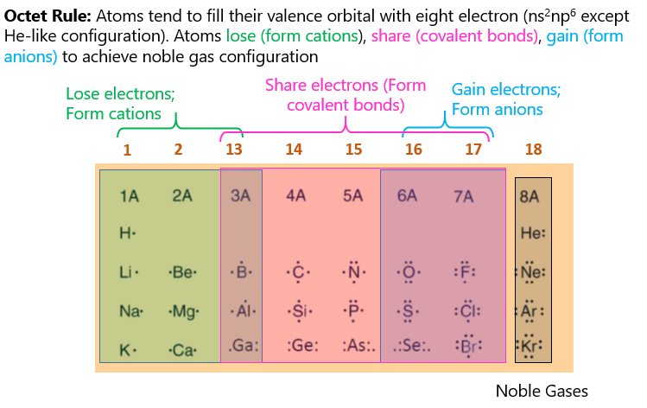

**Ionic Bonding**

Lattice Energy: 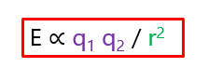

Calculating Lattice Energy

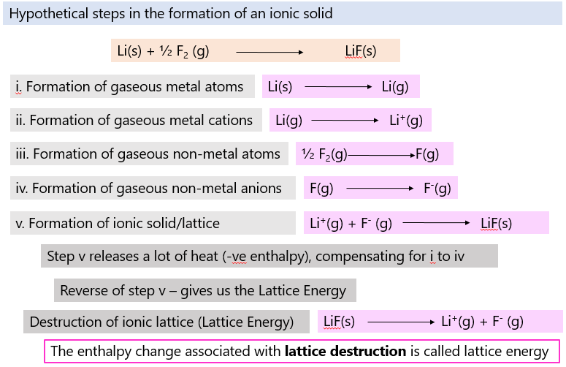

**Covalent Bonding**

**BOND FORMATION BOND ORDER/LENGTH/STRENGTH**

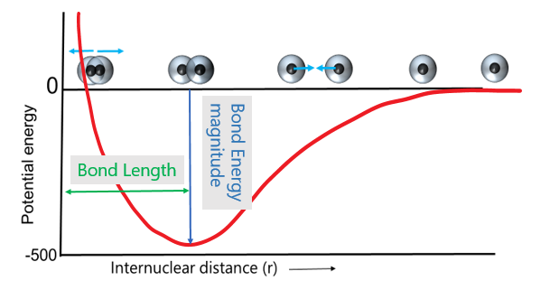 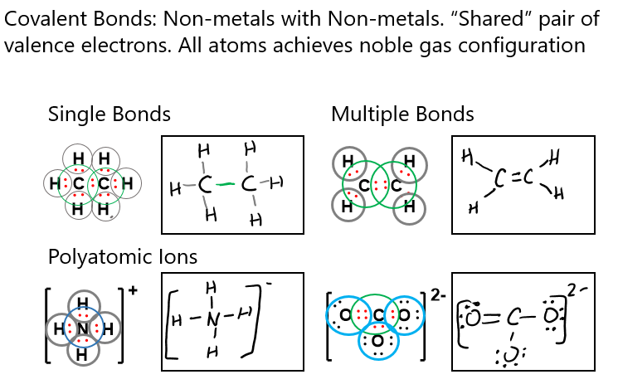

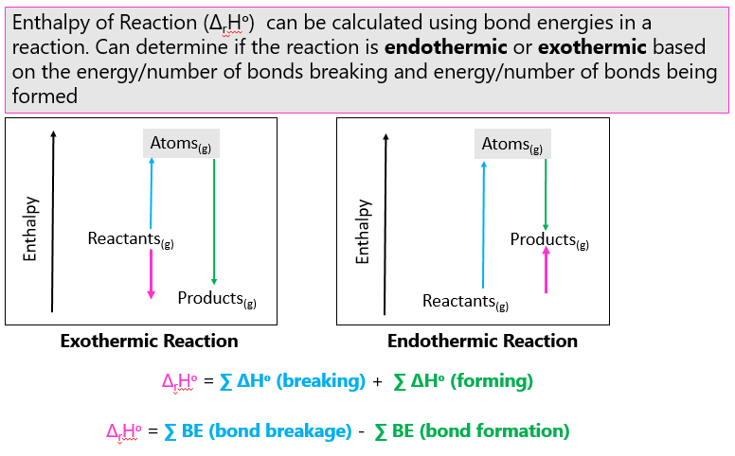**BOND ORDER/LENGTH/STRENGTH BOND ENERGY CALCULATIONS**

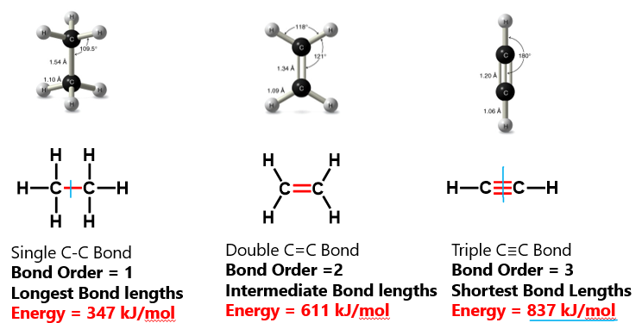

**Review Questions**

**Question 1**

Using the bond energies provided, calculate ΔH for the reaction:

CH4(g) + 4 Cl2 ---- CCl4(g) + 4HCl(g)

Bond energies: C-H = 413 kJ/mol, C-Cl = 339 kJ/mol; H-Cl = 427 kJ/mol, Cl-Cl = 243 kJ/mol

Bonds Breaking: 4 x C-H + 4 x Cl-Cl

Bonds Forming: 4 x C-Cl + 4 x H-Cl

ΔH = (413 x 4) + (243 x 4) – (4 x 339) – (4 x 427)

ΔH = -440 kJ

**Question 2**

The lattice energy of RbCl is the energy change for which process (use a chemical equation to describe the process)?

**RbCl(s)**  Rb+(g) +Cl- (g)

Lattice energy is the energy required to break an ionic lattice to its constituent gaseous ions

Calculate the lattice energy of RbCl using the following data:

|  |  |
| --- | --- |
|  | ∆*H*° (kJ) |
| Rb(*s*)  Rb(*g*) | 86 |
| Rb(*g*)  Rb+(*g*) + e– | 409 |
| Cl2(*g*) 2Cl(*g*) | 242 |
| Cl(*g*) + e– Cl–(*g*) | –355 |
| Rb(*s*) + Cl2(*g*) RbCl(*s*) | –435 |
|  |  |

**Δ**H of overall reaction = enthalpy of atomization (step 1) + ionization energy (step 2) + bond energy (step 3) + electron affinity (step 4) + step 5 (-ve lattice energy)

-435=86+409+ $\frac{1}{2}$*242+(-355)+(-lattice energy)

Lattice energy = 696kJ

**Question 3**

Arrange the following bonds, from the highest to lowest bond energy

Si-Br, Si-I, Si-F, Si-Cl

Si-F> Si-Cl> Si-Br> Si-I

Si is common to all the molecules. The larger the atom that binds to Si atom, the longer the covalent bond between those atoms. The longer the covalent bond, the weaker the bond, and the lower the bond energy. F atom has the smallest radius while I atom has the largest radius.

**Question 4**

Consider the following 2 bonds: P-F and P-Cl.

The bond dissociation energy for one of the bonds is 331 kJ/mol and the other is 490 kJ/mol. Determine which bond dissociation energy corresponds to P-F and P-Cl.

In the figure given below, **draw** two energy diagrams showing the change in energy (y axis) as function of change in the inter-nuclear distance (x axis) for P-F and P-Cl. Label the diagrams as P-F and P-Cl.

Values corresponding to the bond dissociation energies are shown on y axis.

Using a double headed arrow ( ) show the distance that corresponds to the bond length for P-F and P-Cl (No numbers needed).

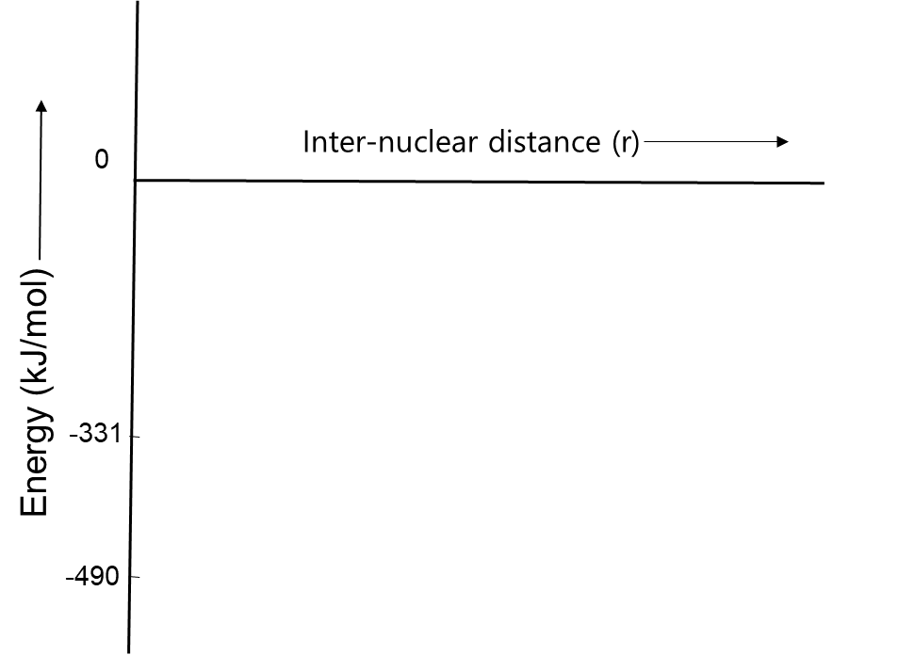

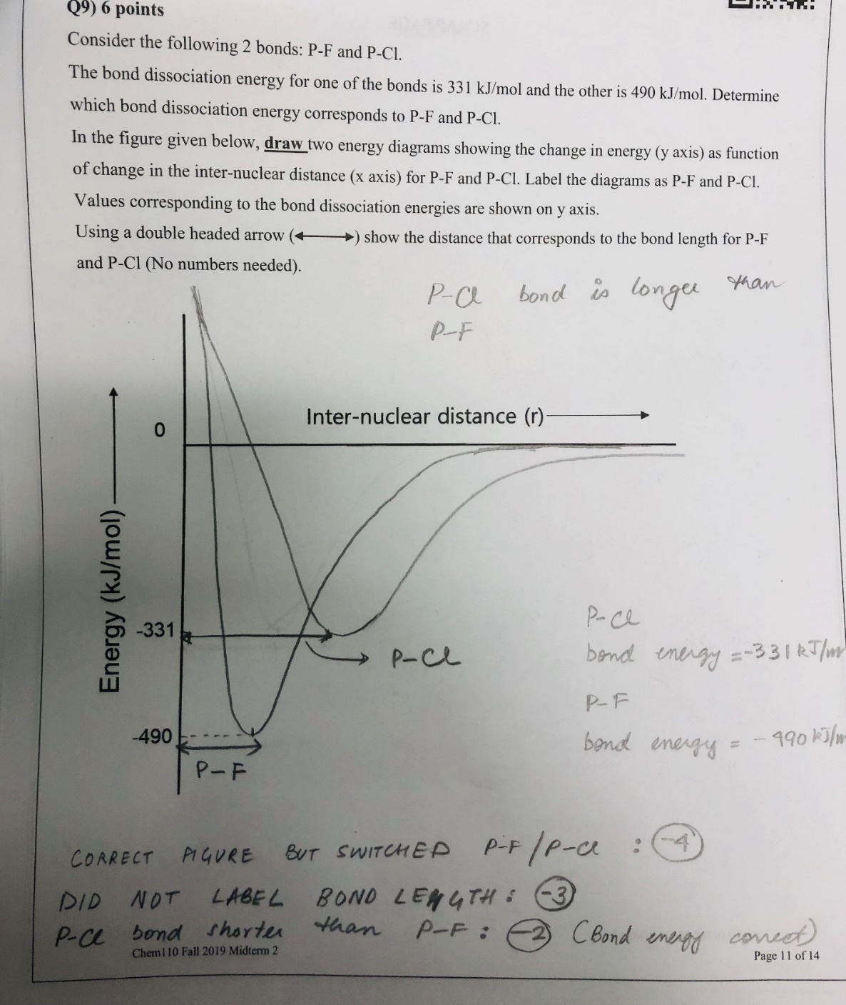

**Question 5**

1. Using the bond energies provided, calculate the enthalpy (kJ/mol) of the following reaction:

C2H4 + HBr 🡪 C2H5Br

C=C = (614 kJ/mol) H–Br = (363 kJ/mol) C–Br = (276 kJ/mol)

C–H = (413 kJ/mol) C–C = (347 kJ/mol)



Reactant bonds broken:

1 x C=C = (614 kJ/mol) = 614 kJ

4 x C–H = 4(413 kJ/mol) = 1652 kJ

1 x H–Br = (363 kJ/mol) = 363 kJ

 = 2629 kJ

Product bonds formed:

5 x C–H = 5(–413 kJ/mol) = –2065 kJ

1 x C–C = (–347 kJ/mol) = –347 kJ

1 x C–Br = (–276 kJ/mol) = –276 kJ

= –2688 kJ

=  + = 2629 kJ + (–2688 kJ) = **–59 kJ**

**Question 6**

Draw the following molecules showing Lewis dot representation (show valence electrons as dots around the atom) of the atom:

CH4 (This molecule is methane: central atom is carbon bonded to 4 hydrogens)



CH3+ (We will learn about calculating formal charges next week, but I want you to try and show this molecule. C with a positive charge - These molecules that have C+ are electron deficient – very crucial for organic chemists due to high reactivity and are known as a carbocation)



CH3- (We will learn about calculating formal charges next week, but I want you to try and show this molecule. C with a negative charge – it has an extra lone pair, is also very crucial for organic chemists and is known as a carbanion)

